United Nations Development Programme

04 April 2013

Dear Mr. Roberto Valent,

Subject: PPG for a Medium-Size Project, Belize Chemicals and Waste Management Programme, – PIMS No. 5158 - ATLAS BU: SLV10 - Proposal No.: 00077232 - Project No.: 00088152

I am pleased to delegate to you the authority to sign the Initiation Plan for the above-mentioned Project Preparation Grant (PPG) / Programme Cooperation Budget (PCB) on behalf of UNDP, and to commence development of the main project. As per Rule 116.05 of the UNDP Financial Regulations and Rules (Executive Board Decision 2005/1), this document becomes effective when signed by the Resident Representative. The Initiation Plan, which amounts to a total of $50,000, has received its final approval in accordance with the established GEF procedures (CEO approval letter for the PPG/PCB attached for ease of reference).

I am also pleased to provide a summary of the next steps in the process and to outline, for your easy reference, the mandatory GEF-specific project financial and results management requirements. In addition, a number of Advisory Notes have been prepared to support the implementation of UNDP supported GEF funded projects, these and further clarification on the GEF project cycle and requirements, can be found in the UNDP GEF Programming Manual at http://intra.undp.org/gef .

Next steps and mandatory GEF-specific requirements:
- Issuance of Authorized Spending Limit (ASL): To facilitate a quick start to the PPG/PCB, once the Initiation Plan is signed, please kindly ensure that the Atlas-generated Annual Work Plan (AWP) based on the Total Budget and Annual Work Plan in the attached document, along with a copy of the signed cover page, is sent to Mr. Kasper Koefoed, Regional Technical Advisor (RTA) in Panama City, Panama.

Any proposed budget revisions should be forwarded to the UNDP RTA together with a clear explanation of the changes proposed as any significant changes require review and approval. In addition, please note that UNDP/GEF is not in a position to increase the project budget above the amount already approved by the GEF Council. Therefore, any over-expenditure on this project would have to be absorbed by other Country Office resources.

- GEF-specific project management requirements:
Any changes contemplated with respect to the project objectives and outcomes will have to be discussed with and approved by the UNDP/GEF RTA, as they will have to be reported to the GEF.

Mr. Roberto Valent
Resident Representative
UNDP El Salvador and Belize

The final full size project must be ready by 13 February 2014 as recorded in the Initiation Plan. The Regional Technical Advisor will advise you of the expected timeline for submission of the final proposal for the purpose of internal UNDP clearance prior to submission to the GEF Secretariat.

The final submission of the full size project that is prepared with this preparation grant must be accompanied by a “GEF PPG/PCB Status Report”. The template can be obtained from the UNDP GEF Programming Manual http://intra.undp.org/gef
This preparatory phase must be operationally completed in Atlas once the main project is endorsed/approved by the GEF CEO. Financial closure should follow within 12 months, but preferably within the same calendar year.
Annex 2 includes a number of key UNDP/GEF management performance indicators that aim to improve the efficiency and effectiveness in the oversight and supervision services provided.

Performance against these indicators will be monitored on an annual basis.
In order to accord proper acknowledgement to the GEF for providing funding, full compliance is needed with the GEF’s Communication and Visibility Guidelines (the “GEF Guidelines”). The GEF Guidelines can be accessed at:

http://www.thegef.org/gef/sites/thegef.org/files/documents/C.40.08_Branding_the_GEF%20final_0.p df. Full compliance is also required with UNDP’s branding guidelines. These can be accessed at http://intra.undp.org/coa/branding.shtml, and specific guidelines on UNDP logo use can be accessed at: http://intra.undp.org/branding/useOfLogo.html.

In concluding, I would like to assure you of UNDP/GEF’s and my personal commitment to a successful implementation of the project. The Regional Technical Advisors are at your disposal for advice and technical support. Should you have any concerns or questions, please do not hesitate to contact me.

Yours sincerely,
Adriana Dinu
UNDP/GEF Officer-in-Charge

cc: Mr. Heraldo Muñoz, Assistant Secretary General and Regional Director UNDP RBLAC
Ms. Suely Carvalho, UNDP GEF Principal Technical Advisor for POPs/ Ozone UNDP/MPU/Chemicals
Mr. Chris Briggs, UNDP-EEG Regional Team Leader, Latin America and the Caribbean
Mr. Kasper Koefoed-Hansen, UNDP GEF Regional Technical Advisor Panama City, Panama
Ms. Carolina Dreikon, National Program Officer UNDP El Salvador and Belize
Annexes

Annex 1 CEO approval letter for PPG/PCB
Annex 2 Project Support Services

Annex 1: CEO approval letter for PPG/PCB

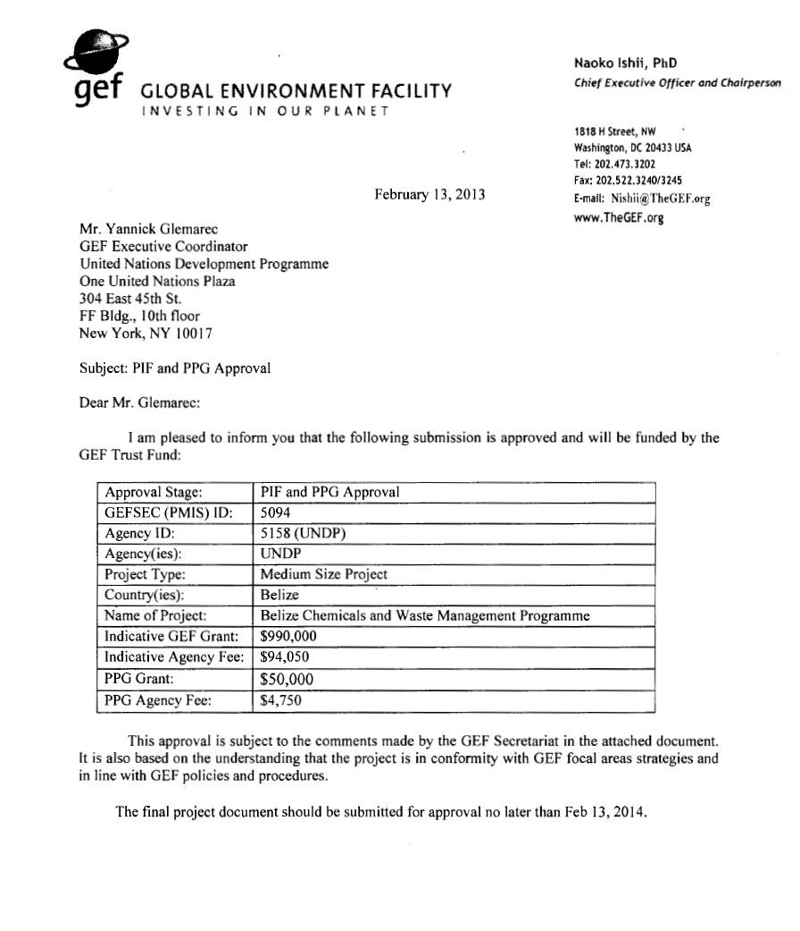

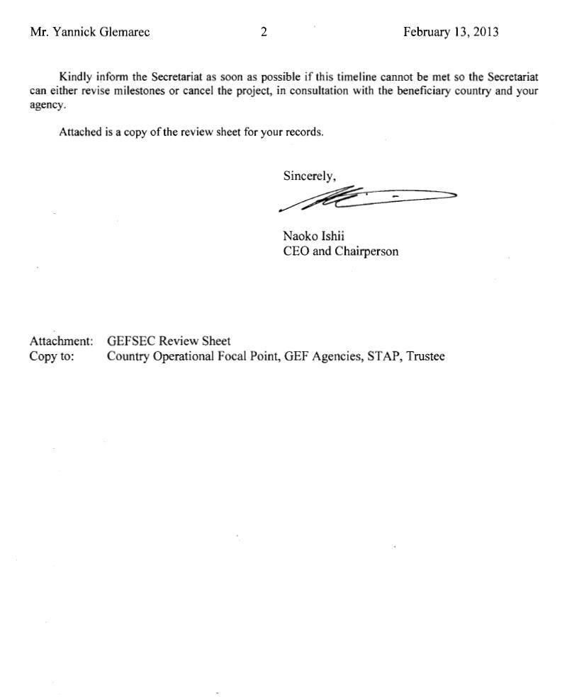

Annex 2: Project Support Services

Stage | Country Office | UNDP/GEF
Identification,  Sourcing/Screening of Ideas, and Due  Diligence | Identify project ideas as part of country programme/CPAP and UNDAF/CCA. | Technical input to CCA/UNDAFs and CPAPs where appropriate.  Input on policy alignment between projects and programmes.  Provide information on substantive issues and specialized funding opportunities (SOFs). Policy advisory services including identifying, accessing, combining and sequencing financing.  Verify potential eligibility of identified idea.
 | Assist proponent to formulate project idea / prepare project idea paper (e.g. GEF PIF/PPG/PCB). | Technical support:  Research and development.  Provide up-front guidance.  Sourcing of technical expertise.  Verification of technical reports and project conceptualization.  Guidance on SOF expectations and requirements.  Training and capacity building for Country Offices.
 | Appraisal:  Review and appraise project idea.  Undertake capacity assessments of implementing partner as per UNDP POPP.  Environmental screening of project as and when included in UNDP POPP.  Monitor project cycle milestones. | Provide detailed screening against technical, financial, social and risk criteria.  Determine likely eligibility against identified SOF.
 | Partners:  Assist proponent to identify and negotiate with relevant partners, cofinanciers, etc | Assist in identifying technical partners.  Validate partner technical abilities.
 | Obtain clearances:  Government, UNDP, Executing Agency, LPAC, cofinanciers, etc. | Obtain SOF clearances.
Project  Development | Initiation Plan:  Management and financial oversight of  Initiation Plan  Discuss management arrangements | Technical support, backstopping and troubleshooting.  Support discussions on management arrangements  Facilitate issuance of DOA

Stage | Country Office¹ | UNDP/GEF
 | Project Document:  Support project development, assist proponent to identify and negotiate with relevant partners, cofinanciers, etc. Review, appraise, finalize Project Document.  Negotiate and obtain clearances and signatures – Government, UNDP, Implementing Partner, LPAC, cofinanciers, etc.  Respond to information requests, arrange revisions etc.  Prepare operational and financial reports on development stage as needed. | Technical support:  Sourcing of technical expertise.  Verification of technical reports and project conceptualization.  Guidance on SOF expectations and requirements.  Negotiate and obtain clearances by SOF  Respond to information requests, arrange revisions etc.  Quality assurance and due diligence. Facilitate issuance of DOA
Key UNDP/GEF man | agement performance indicators/targets for Proje | ct Development:
1. Time between PI | F approval to CEO endorsement for each project:
Target f | or GEF trust fund project: FSP = 18 months or le | ss, MSP 12 months or less.
Target f | or LDCF and SCCF: FSP/MSP = 12 months or l | ess.
2. Time between C | EO endorsement (or PAC for non GEF funded pro | jects) to first disbursement for each project:
Target | 4 months or less  =
Project Oversight | Management Oversight and support | Technical and SOF Oversight and support
 | Project Launch/Inception Workshop Preparation and coordination. | Technical support in preparing TOR and verifying expertise for technical positions.  Verification of technical validity / match with SOF expectations of inception report. Participate in Inception Workshop
 | Management arrangements:  Facilitate consolidation of the Project Management Unit, where relevant. Facilitate and support Project Board meetings as outlined in project document and agreed with UNDP RTA.  Provide project assurance role if specified in project document. | Technical input and support to TOR development.  Troubleshooting support.  Support in sourcing of potentially suitable candidates and subsequent review of CVs/recruitment process.
 | Annual WorkPlan:  Issuance of AWP.  Monitor implementation of the annual work plan and timetable. | Advisory services as required  Review AWP, and clear for ASL where relevant.
 | Financial management:  Conduct budget revisions, verify expenditures, advance funds, issue combined delivery reports, ensure no over-expenditure of budget.  Ensure necessary audits. | Allocation of ASLs, based on cleared AWPs  Return of unspent funds to donor  Monitor projects to ensure activities funded by donor comply with agreements/ProDocs  Oversight and monitoring to ensure financial transparency and clear reporting to the donor

Stage | Country Office¹ | UNDP/GEF
 | Results Management:  Alignment: link project output to CPAP  Outcome in project tree in Atlas, link  CPAP outcome in project tree to UNDP Strategic Plan Environment and sustainable Development Key Result Area as outlined in project document during UNDP work planning in ERBM. Gender: In ATLAS, rate each output on a scale of 0-3 for gender relevance. Monitoring and reporting: Monitor project results, track result framework indicators, and co-financing where relevant. Monitor risks in Atlas and prepare annual APR/PIR report where required by donor and/or UNDP/GEF. Annual site visits – at least one site visit per year, report to be circulated no later than 2 weeks after visit completion. | Advisory services as required.  Quality assurance.  Project visits – at least one technical support visit per year.
 | Evaluation:  Integrate project evaluations into CO evaluation plan. Identify synergies with country outcome evaluations. Arrange mid-term, final, and other evaluations: prepare TOR, hire personnel, plan and facilitate mission / meetings / debriefing, circulate draft and final reports.  Participate as necessary in other evaluations.  Ensure tracking of committed and actual co financing as part of mid-term and final evaluations.  Prepare management response to project evaluations and post in UNDP ERC. | Technical support and analysis.  Quality assurance.  Compilation of lessons and consolidation of learning.  Dissemination of technical findings.  Participate as necessary in other SOF evaluations.
 | Project Closure:  Final budget revision and financial closure (within 12 months after operational completion).  Final reports as required by donor and/or  UNDP/GEF. | Advisory services as required.  Technical input.  Quality assurance.
Stage | Country Office¹ | UNDP/GEF
Key UNDP/GEF management performance indicators/targets for Project Oversight:
- Each project aligned with country outcomes and UNDP Strategic Plan Environment and Sustainable Development key results, and included in Country Office Integrated Work Plan in the ERBM: Target = 100%

- Quality rating of annual APR/PIRs: Once completed and submitted, the quality of each project APR/PIR is rated by an external reviewer

Target = Rating of Satisfactory or above
- Quality rating of Terminal Evaluations: Once completed, the quality of each terminal evaluation is rated by an external reviewer

Target = Rating of Satisfactory or above
- Quality of results achieved by project as noted in terminal evaluation: the independent evaluator assigns an overall rating to the project.

Target = Satisfactory or above

As per UNDP POPP with additional SOF requirements where relevant.

